Problem Statement:

We have a dataset of sales of different TV sets across different
locations.

Records look like:

Samsung|Optima|14|Madhya Pradesh|132401|14200

The fields are arranged like:

Company Name|Product Name|Size in inches|State|Pin Code|Price

6. Modify Task 3 (refer session 4, assignment 2) to take advantage of Combiner.

7. Write a Map Reduce program to view the total sales for each product for every Company

corresponding to each size.

Make sure that all records for a single company goes to a single reducer and inside every

reducer, keys must be sorted

in descending order of the size.

You may write a custom WritableComparable for this purpose.

Task6.java

package assignment5_2;

/**
* <h1>Task6</h1>
* This class will be used to define the configuration components for the given task
* here we are using reducer
* the reducer will simply sum together the count value associated with each map output key
* */

import org.apache.hadoop.fs.Path;
import org.apache.hadoop.conf.*;
import org.apache.hadoop.mapreduce.Job;
import org.apache.hadoop.mapreduce.lib.input.FileInputFormat;
import org.apache.hadoop.mapreduce.lib.input.TextInputFormat;
import org.apache.hadoop.mapreduce.lib.output.FileOutputFormat;
import org.apache.hadoop.mapreduce.lib.output.TextOutputFormat;
import org.apache.hadoop.io.IntWritable;
import org.apache.hadoop.io.Text;

public class Task6 {
public static void main(String[] args) throws Exception {
Configuration conf = new Configuration();
Job job = new Job(conf, "Task6");
job.setJarByClass(Task6.class);

job.setMapOutputKeyClass(Text.class);
job.setMapOutputValueClass(IntWritable.class);

job.setOutputKeyClass(Text.class);
job.setOutputValueClass(IntWritable.class);
job.setMapperClass(Task6Mapper.class);
job.setReducerClass(Task6Reducer.class);
//combiner will use Task6Reducer class
job.setCombinerClass(Task6Reducer.class);

job.setInputFormatClass(TextInputFormat.class);
job.setOutputFormatClass(TextOutputFormat.class);

FileInputFormat.addInputPath(job, new Path(args[0]));
FileOutputFormat.setOutputPath(job,new Path(args[1]));

job.waitForCompletion(true);
}
}

Task6Mapper.java

package assignment5_2;

import java.io.IOException;

import org.apache.hadoop.io.IntWritable;
import org.apache.hadoop.io.LongWritable;
import org.apache.hadoop.io.Text;
import org.apache.hadoop.mapreduce.*;

public class Task6Mapper extends Mapper<LongWritable, Text, Text, IntWritable> {
Text outKey = new Text();
IntWritable outValue = new IntWritable();

public void map(LongWritable key, Text value, Context context)
throws IOException, InterruptedException {
//every line will be split based on '|' and will be stored in String array
String[] lineArray = value.toString().split("\\|");
//if the company name is "ONIDA" put as mapper output key separated by state name
if(lineArray[0].equalsIgnoreCase("ONIDA")) {
outKey.set("ONIDA" + "\t" + lineArray[3]);
outValue.set(1);
context.write(outKey, outValue);
}
}
}

Task6Reducer.java

package assignment5_2;

import java.io.IOException;

import org.apache.hadoop.io.IntWritable;
import org.apache.hadoop.io.Text;
import org.apache.hadoop.mapreduce.Reducer;

public class Task6Reducer extends Reducer<Text, IntWritable, Text, IntWritable>{
IntWritable outValue = new IntWritable();

public void reduce(Text key, Iterable<IntWritable> values,Context context) throws IOException, InterruptedException{
//we are taking the mapper class output and adding up all the values
//to get the total units sold in each state for "ONIDA" company
int sum = 0;
for (IntWritable value : values) {
sum += value.get();
}

outValue.set(sum);
context.write(key, outValue);
}
}

Command:

Hadoop jar Task6.jar assignment5_2.Task6 /user/acadgild/hadoop/dataset.txt /user/acadgild/hadoop/task6

hadoop fs -cat /user/acadgild/hadoop/task6/part-r-00000

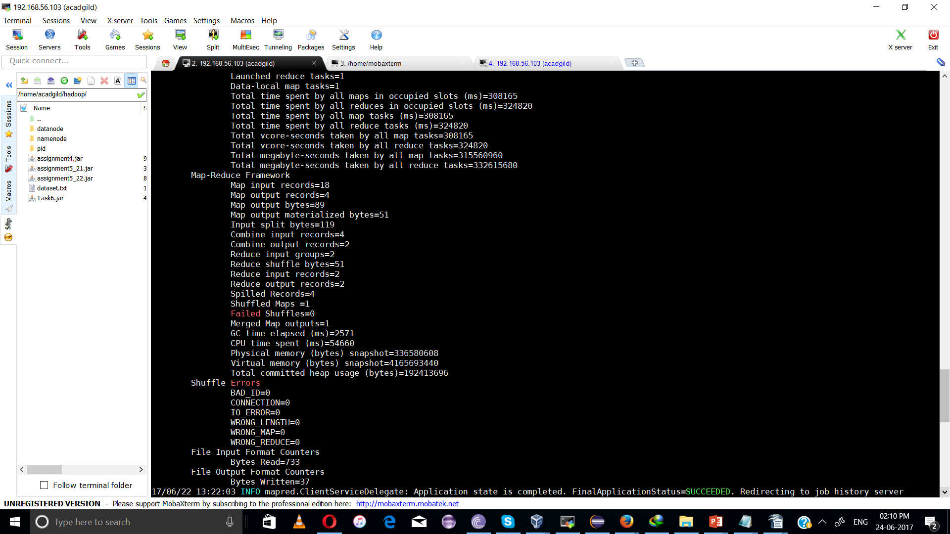

output:
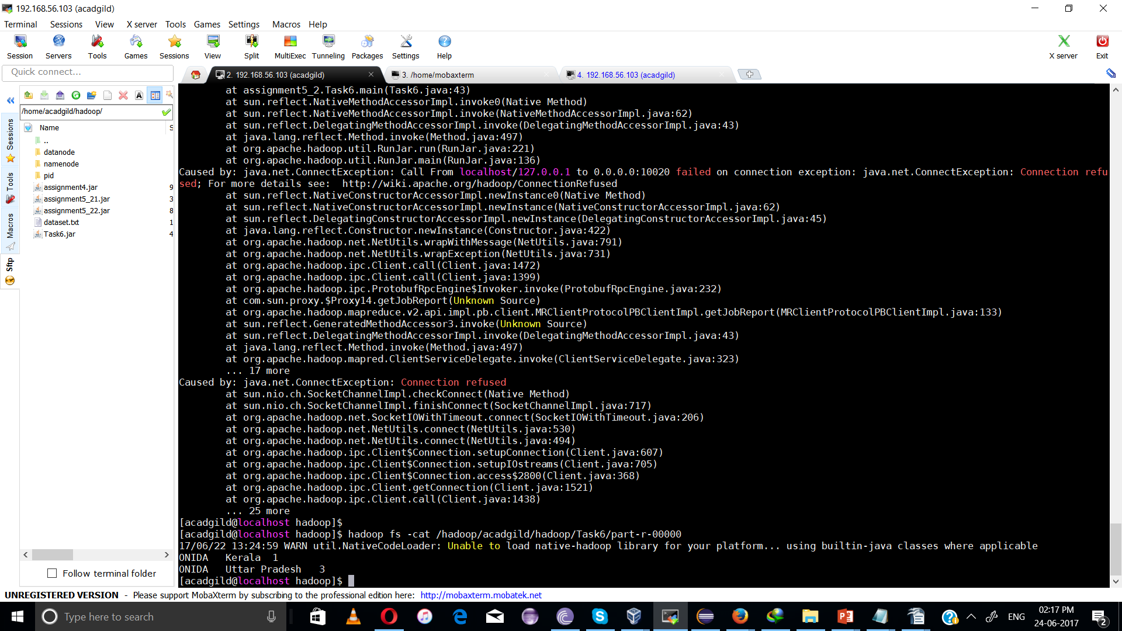

2)

Task7.java

package assignment5_2;

import org.apache.hadoop.fs.Path;
import org.apache.hadoop.conf.*;
import org.apache.hadoop.mapreduce.Job;
import org.apache.hadoop.mapreduce.lib.input.FileInputFormat;
import org.apache.hadoop.mapreduce.lib.input.TextInputFormat;
import org.apache.hadoop.mapreduce.lib.output.FileOutputFormat;
import org.apache.hadoop.mapreduce.lib.output.TextOutputFormat;
import org.apache.hadoop.io.IntWritable;

public class Task7 {
public static void main(String[] args) throws Exception {
Configuration conf = new Configuration();
Job job = new Job(conf, "Task7");
job.setJarByClass(Task7.class);

//map output key will use SortTV class
job.setMapOutputKeyClass(SortTV.class);
job.setMapOutputValueClass(IntWritable.class);

//map output key will use SortTV class
//to ensure inside every reducer, keys are sorted
job.setOutputKeyClass(SortTV.class);
job.setOutputValueClass(IntWritable.class);

job.setMapperClass(Task7Mapper.class);
job.setReducerClass(Task7Reducer.class);

//it will set the number of reducer tasks equal to 4
job.setNumReduceTasks(4);

job.setInputFormatClass(TextInputFormat.class);
job.setOutputFormatClass(TextOutputFormat.class);

FileInputFormat.addInputPath(job, new Path(args[0]));
FileOutputFormat.setOutputPath(job,new Path(args[1]));

job.waitForCompletion(true);
}
}

Task7Mapper.java

package assignment5_2;

import java.io.IOException;

import org.apache.hadoop.io.IntWritable;
import org.apache.hadoop.io.LongWritable;
import org.apache.hadoop.io.Text;
import org.apache.hadoop.mapreduce.*;

public class Task7Mapper extends Mapper<LongWritable, Text, SortTV, IntWritable> {
//mapper output key will be of SortTV type
SortTV outKey = new SortTV();
IntWritable outValue = new IntWritable();

public void map(LongWritable key, Text value, Context context)
throws IOException, InterruptedException {
//every line will be split based on '|' and will be stored in String array
String[] lineArray = value.toString().split("\\|");
//output key for mapper class
outKey.set(lineArray[0],Integer.parseInt(lineArray[2]));
//output value for mapper class
outValue.set(1);
context.write(outKey, outValue);
}
}

Task7Reducer.java

package assignment5_2;

import java.io.IOException;

import org.apache.hadoop.io.IntWritable;
import org.apache.hadoop.mapreduce.Reducer;

public class Task7Reducer extends Reducer<SortTV, IntWritable, SortTV, IntWritable>
{
IntWritable outValue = new IntWritable();
//input key to reducer is of SortTV type which will be in sorted order based on company name and tv size
public void reduce(SortTV key, Iterable<IntWritable> values,Context context) throws IOException, InterruptedException
{
//we are taking the value of mapper class which is (1) and adding up all the values
//to get the total units sold for each company
int sum = 0;
for (IntWritable value : values) {
sum += value.get();
}

//output of reducer is total number of units sold for each company
outValue.set(sum);
context.write(key, outValue);
}
}

SortTV.java
package assignment5_2;

/**
* <h1>SortTV</h1>
* This class is implementing WritableComparable interface to give reducer
* input key in sorted manner based on company name and tv size
* */

import java.io.DataInput;
import java.io.DataOutput;
import java.io.IOException;

import org.apache.hadoop.io.WritableComparable;

public class SortTV implements WritableComparable<SortTV> {

private String company;
private int size;

public String getCompany() {
return company;
}

public int getSize() {
return size;
}

public void set(String company, int size) {
this.company = company;
this.size = size;
}

@Override
// This method is inherited from Writable interface and will be used to deserialize the fields of the object from ‘in’.
public void readFields(DataInput in) throws IOException {
company = in.readUTF();
size = in.readInt();
}

@Override
// This method is inherited from Writable interface and will be used to serialize the fields of the object to ‘out’.
public void write(DataOutput out) throws IOException {
out.writeUTF(company);
out.writeInt(size);
}

@Override
//this method is inherited from Object class and is used to print user defined objects accordingly
public String toString() {
return company + "\t" + size;
}

@Override
// This method is inherited from Comparable interface and will be used to sort the input keys to reducer
//based on hashcode and equals method
public int compareTo(SortTV tv) {
int cmp = this.company.compareTo(tv.company);

if (cmp != 0) {
return cmp;
}

return (-1) * (this.size - tv.getSize());
}

@Override
public int hashCode(){
return company.hashCode();
}

@Override
public boolean equals(Object o)
{
if(o instanceof SortTV)
{
SortTV tv = (SortTV) o;
return company.equalsIgnoreCase(tv.company) && (size == tv.getSize());
}
return false;
}

}

Command:

Hadoop jar Task7.jar assignment5_2.Task7 /user/acadgild/hadoop/dataset.txt /user/acadgild/hadoop/task7

hadoop fs -cat /user/acadgild/hadoop/task7/part-r-00000

hadoop fs -cat /user/acadgild/hadoop/task7/part-r-00001

hadoop fs -cat /user/acadgild/hadoop/task7/part-r-00002

hadoop fs -cat /user/acadgild/hadoop/task7/part-r-00003

